**Overview**

In modern day architectures, we extract data from data silos using pipelines. Our data model is built on the data from different sources. Most of the times, pipelines run daily at a certain time and Power BI semantic model is often set to “Schedule Refresh” after that time assuming success of data pipelines.

However, in real life scenarios, pipelines do get failed due to some unexpected issues. In such cases, Power BI semantic model refresh still runs and we may not have the latest data in the reports. This disconnected approach is not very intuitive.

**Solution**

Building a pipeline which will be responsible for carrying out Power BI semantic model refresh (via API) and adding this pipeline in series after our daily master pipeline.

**Prerequisites**

1. Azure Data Factory
2. Ability to change Tenants settings in Power BI Service
3. Ability to create Security Group in Microsoft Entra ID (formerly Azure Active Directory)

**Steps**

1. Create a security group in Microsoft Entra ID

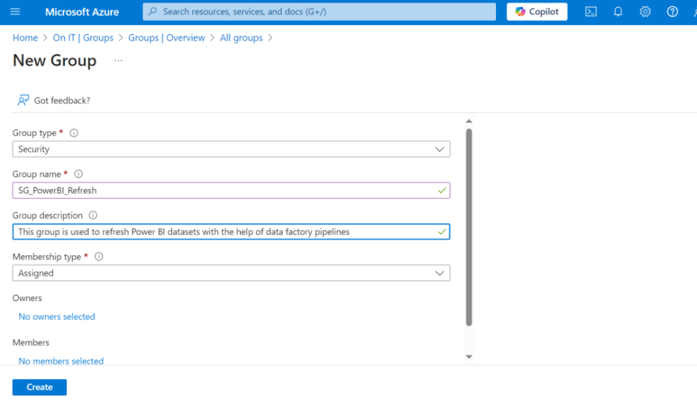

1. Add a service principal or the name of your data factory as a "Member” of this Security Group

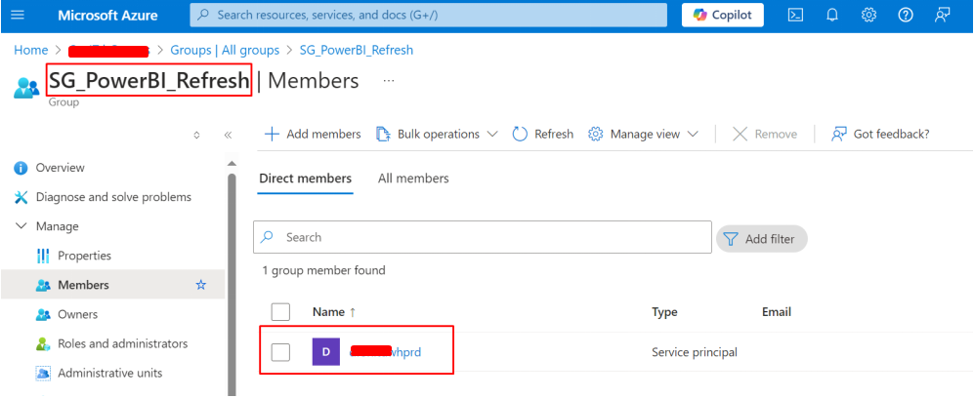

1. Head to Power BI service, in Admin portal under Tenant settings, enable the following setting and add the security group in it.

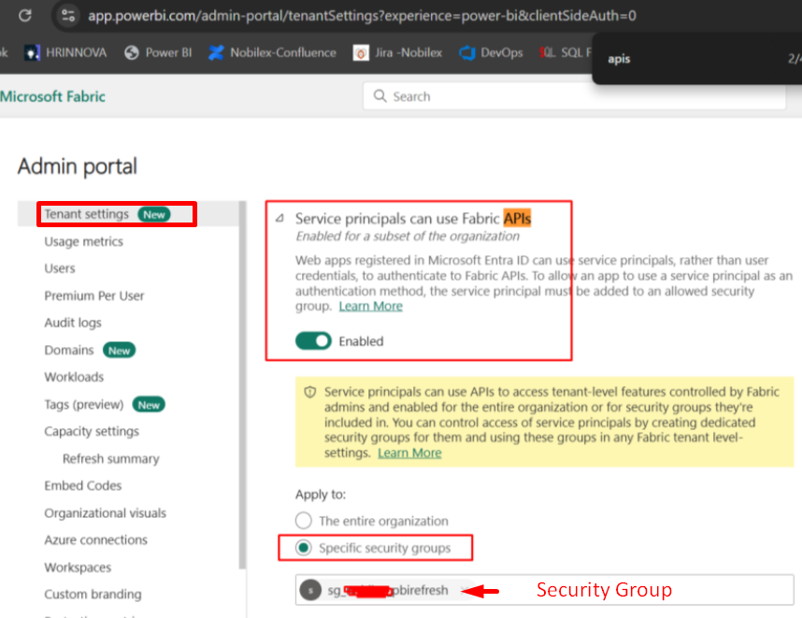 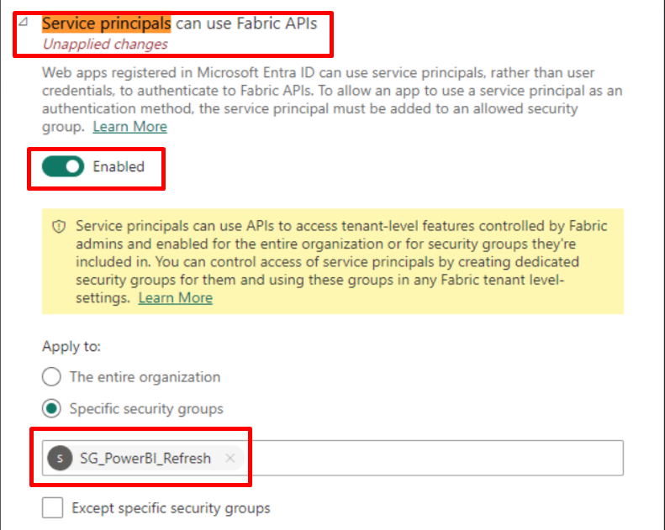

1. Assign the “Admin” role to the same security group for the workspace in which your semantic model (to be refreshed) is present.

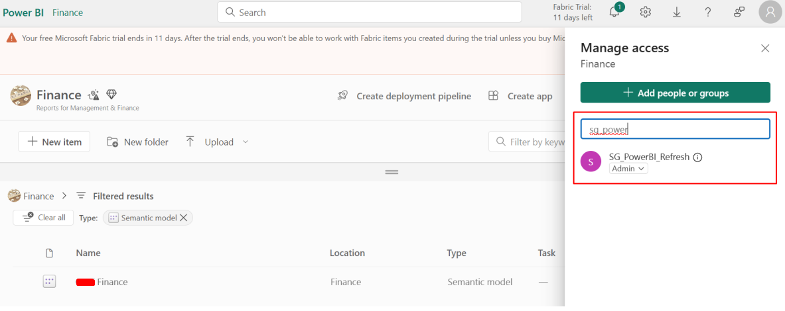

1. Head to Azure Data Factory to create a pipeline. Use the JSON code available in the same folder of this document and paste the code in you data factory. (Remember when you create new pipeline, you need to give the same name to it as it is mentioned in the JSON code)

Once you paste the JSON code, your pipeline will look like following:

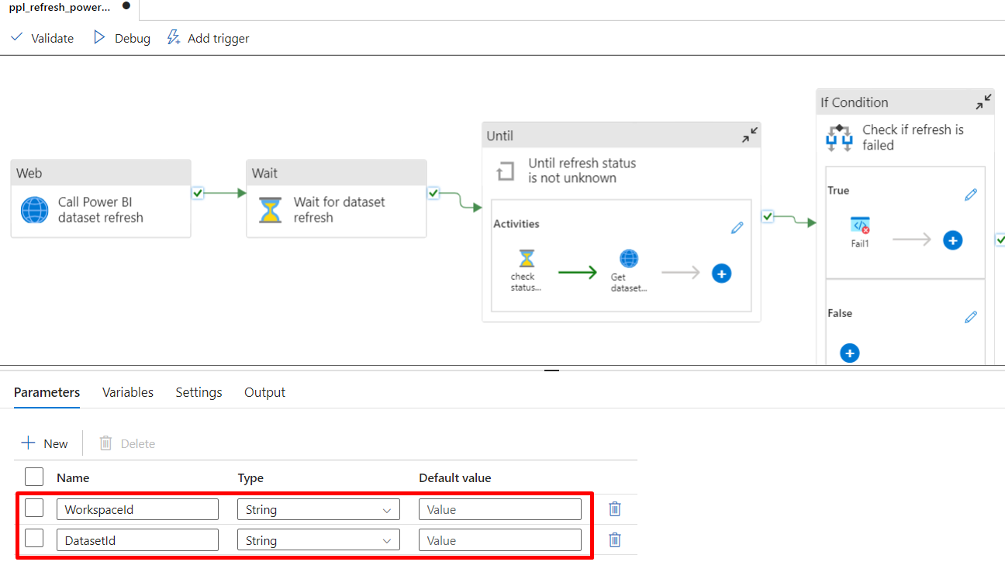

1. You must have noticed that the pipeline has two parameters. One for Workspace ID and another for Dataset ID. We need to pass these values when debugging the pipeline.
2. To find the Workspace ID and Dataset ID, you need to open your semantic model in Power BI Service. In the URL, the part after groups is your Workspace ID and the part after datasets is your Dataset ID.

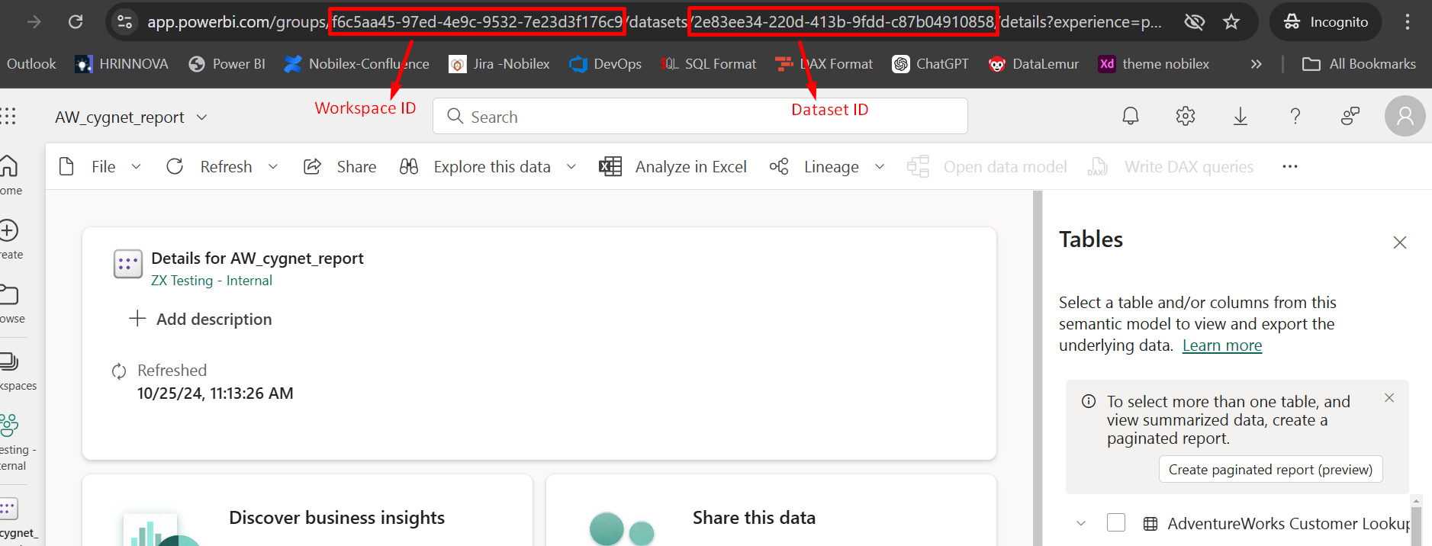

1. Just pass these parameter values and your dataset is refreshed. Please note that this pipeline also checks the dataset refresh status after a certain interval (usually every 1 minute). This is optional and you can configure this interval time inside “Until” activity.
2. The last “If condition” checks if the refresh is status is failed the it will fail the pipeline. If you have configured alerts for the failed pipelines, you will also get email notification for the same.